MRR: Drone Design

Contributor(s):

Shallwin Silvania – contact: [shallwinsilvania@gmail.com](mailto:shallwinsilvania@gmail.com) / +06 16866849 (2022)

|  |  |  |
| --- | --- | --- |
| **Version:** | **Date:** | **Changes:** |
| Incomplete V1.0 | 11/9/2022 | Start |
| Incomplete V1.1 | 19/9/2022 | Background, first model |
| Incomplete V1.2 | 23/9/2022 | Second model |
| Incomplete V2.0 | 29/9/2022 | Sketches |
| Incomplete V2.1 | 3/10/2022 | Third model |
| Incomplete V3.0 | 14/10/2022 | Changed file according to feedback. |
| Complete V1.0 | 26/10/2022 | Added last model and conclusion. |

Contents

Introduction 4

Drone Dimensions 5

Drone Design Background 6

Drone Cap Design 7

Conclusion 14

Summary 15

# Introduction

In this document the processes of the design for the body of the test drone will be explained. This document will show the reasons impact of the design and feedback received on sed design.

# Drone Dimensions

The following passage is about the dimensions of the current test drone. These dimensions will be used when making 3D models for the drone. This information is very useful for the modelers that will be working on the drone part design.

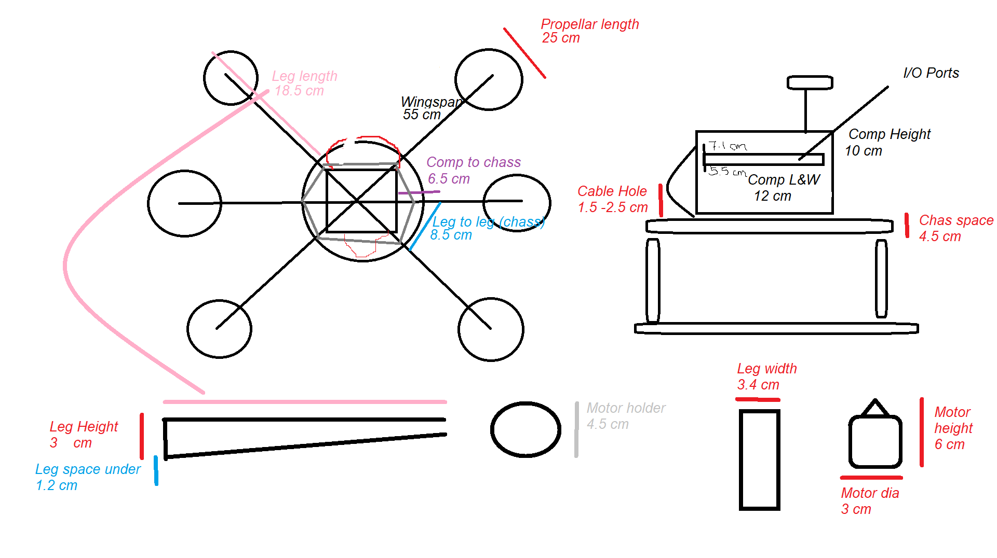

**Leg dimensions**

* Wingspan = 55 cm
* Distance between legs at chassis suggestion = 8.5 cm
* Leg length = 18.5
* Leg height = 3 cm
* Leg width = 3.4cm
* Motor holder diameter = 4.5 cm
* Motor height = 6 cm
* Motor diameter = 3 cm
* Propeller length = 25 cm

**Body dimensions**

* Distance between components and chassis suggestion = 6.5 cm
* Component height min = 10 cm
* Component length = 12 cm
* Component width = 12cm
* Cable opening = 1.5 – 2,5 cm of Component height min
* Ports opening = 5.5 – 7.5 cm of Component height min

# Drone Design Background

In this passage the design rules are setup, rules being that the designer should take the following background information into consideration when designing parts for aircrafts. A quick search for drones will show you the following:

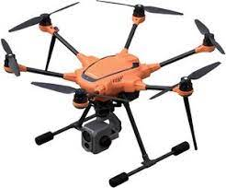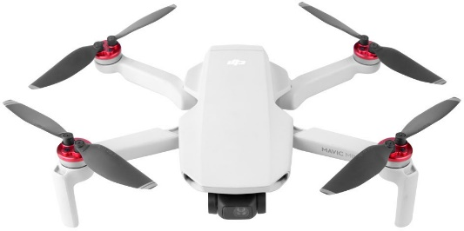

These are commercial/professional drones, and they all have something in common. Namely their body shape, most if not all professional drones have a streamlined and symmetric shape. This led to the following research on aerodynamics:

Fluid Dynamics play a significant role in the development of drones (and aircraft). In Aerodynamics there are 4 forces that act on aircrafts. The 4 forces are the following:

1. Weight – The gravitational force weighing down the aircraft
2. Lift – The vertical force lifting the aircraft
3. Thrust – The directional force acting on the aircraft
4. Drag – The opposing force acting against the directional force (air resistance)

These for 4 forces are based on Newton’s third law of motion that being for every action (force) there is an opposing reaction (force). For a better understanding of this law, you can watch this video: <https://www.youtube.com/watch?v=TVAxASr0iUY>

For the design part of the body there will be heavy focus on the drag since drone solely rely on their lift force (& momentum of course) to thrust into different directions. The focus of the design will be on minimizing drag by using shapes that help minimize air resistance.

# Drone Cap Design

In this passage the prototypes of the drone cap will be shown along with their reasoning and feedback from the stakeholder.

This image gives a visual representation of how the air flow should look in a multirotor drone. Based on research done comparing the drag coefficient of spherical and flat object it was concluded that spherical shapes get lower amounts of air resistance than shapes with flat surfaces. A teardrop has theoretically the least amount of drag but is not a practical shape for drone design.

For this reason, a spherical cap will be design to improve the aerodynamics of the drone by reducing the drag. The following will be done to design the cap:

* Get/make a 3D model of the center plate of the test drone
* 3D model a cap
* If possible, run CFD simulation to test drag (Outstanding)

.

This sketch was made to create the first prototype.

Positive

* Sturdiness (focus)
* Moderately aerodynamic

Negatives

* Heavy

Feedback

* Disliked design (looks too much like a tank)
* Too heavy
* Focus should be on looks

From the feedback the following sketch was made.

This sketch led to the following base model. That required more feature to make it look prettier.

Positive

* Light
* Good aerodynamics

Negative

* Weak protection

Feedback

* Disliked shape (looks too much like an egg)
* Wants something between the first and second design

As a design guide the following sketches were made in hopes of getting the stakeholder’s vision. The stakeholder never had an answer when asked what the design vision was for the drone.

Feedback

* No answer received

The following design was made & printed after not receiving a response from the stakeholder. This printed model was presented to the stakeholder.

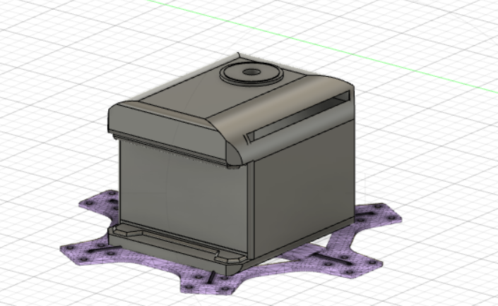

Positive

* Light
* Sturdy
* pretty

Negative

* lower aerodynamics

feedback

* Was happy with the design
* Size adjustment needed
* Add/adjust holes (GPS, button etc.)
* Make sides smoother

Based on the feedback and own initiative the following was produced.

Positive

* Lighter than previous version
* More space
* Has design aspects making it prettier but also more promotable
* A bit more aerodynamic than previous model

Negatives

* Not the most aerodynamics cap
* A bit vulnerable to weather damage due to airflow holes

# Conclusion

Based on the feedback received it was concluded that the last model would be the new cap for the test drone. The stakeholder liked the design and believed that it had met all their requirements (which was not known from the start).

# Summary

<https://cfdflowengineering.com/working-principle-and-components-of-drone/>

<https://cfdflowengineering.com/essentials-of-fluid-mechanics-for-cfd-engineers/>

<https://www.grc.nasa.gov/www/k-12/airplane/shaped.html#:~:text=A%20quick%20comparison%20shows%20that,the%20amount%20of%20drag%20produced>.

<https://www.researchgate.net/publication/330684511_Shape_effects_on_drag>